**Introduction**

Votify is an innovative digital platform designed to enable secure, efficient, and accessible voting over the internet. By leveraging robust authentication and encryption measures, Votify aims to streamline the election process, allowing voters to participate from anywhere. It addresses the limitations of traditional voting systems by ensuring the confidentiality and integrity of votes, making it suitable for various election contexts.

**Key Features:**

1. **Authentication and Security:**

**Robust Authentication:** Votify employs multiple layers of authentication, including password protection, OTP (One-Time Password) verification, and biometric identification (fingerprint or facial recognition). This ensures that only eligible voters can access the system and cast their votes.

**End-to-End Encryption:** All data transmitted within the system is encrypted to prevent unauthorized access and tampering. This guarantees that votes remain confidential and secure throughout the process.

**Secure Storage:** Votes are stored in an encrypted database, safeguarding them against data breaches and ensuring that they cannot be altered once cast.

1. **Accessibility and Inclusivity:**

**Multi-Device Compatibility:** Votify is designed to be accessible on various devices, including desktop computers, laptops, tablets, and smartphones. This allows voters to participate in elections from the comfort of their own homes or while on the go.

**User-Friendly Interface:** The platform features an intuitive interface that is easy to navigate, even for individuals with limited technical skills. It also includes accessibility features, such as screen readers and text magnification, to accommodate voters with disabilities.

**Language Support:** Votify supports multiple languages, making it inclusive for diverse populations and ensuring that language barriers do not hinder voter participation.

1. **Efficiency and Cost-Effectiveness:**

**Automated Processes:** The system automates various aspects of the election process, including voter registration, ballot distribution, vote counting, and result reporting. This reduces the need for manual intervention, minimizing the chances of human error and speeding up the entire process.

**Cost Savings:** By eliminating the need for physical polling stations, paper ballots, and manual vote counting, Votify significantly reduces the operational costs associated with traditional voting methods. These savings can be redirected towards other essential services or initiatives.

1. **Transparency and Accountability:**

**Audit Trails:** Votify maintains comprehensive audit trails that record all actions taken within the system. This enables election authorities to track and verify each step of the voting process, ensuring transparency and accountability.

**Real-Time Monitoring:** Election officials can monitor the progress of the election in real-time, gaining insights into voter turnout, vote counts, and potential issues. This allows for prompt resolution of any problems that may arise.

1. **Suitability for Various Election Contexts:**

* **Governmental Elections:** Votify is capable of handling large-scale elections at the national, state, or local levels. Its security measures and scalability make it ideal for ensuring the integrity of democratic processes.
* **Corporate Elections:** Companies can use Votify to conduct board elections, shareholder votes, and other corporate decision-making processes efficiently and securely.
* **Organizational Elections:** Non-profit organizations, academic institutions, and other groups can leverage Votify to facilitate fair and transparent elections for leadership positions, policy decisions, and other matters.

**Problem Definition and Scope**

**Problem Definition**

Traditional voting systems face several challenges:

* **Logistical Issues**: Manual vote collection and counting are time-consuming and prone to errors.
* **Security Concerns**: Physical voting is vulnerable to fraud and tampering.
* **Accessibility**: Physical polling stations may not be accessible to all, especially those with disabilities or living in remote areas.

**Scope**

* **Platform Accessibility**: Accessible on computers, tablets, and smartphones.
* **Scalability and Reliability**: Capable of handling elections from small organizations to large national events.
* **Future Enhancements**: Includes potential for biometric authentication, mobile optimization, and integration with national identification systems.

**Goals and Objectives**

* **Transparency and Trust**: Enhance trust in the election process with clear, auditable records.
* **Accessibility**: Create an inclusive platform accessible to people with disabilities.
* **Cost Efficiency**: Reduce operational costs by automating vote collection
* and counting.
* **Security and Integrity**: Ensure the confidentiality and integrity of votes through strong encryption and authentication.

**Major Constraints and Outcomes**

**Major Constraints**

* Ensuring high levels of security to prevent hacking and fraud.
* Maintaining voter anonymity while ensuring accurate vote counting.
* Providing a user-friendly interface that is accessible to all users.

**Expected Outcomes**

* A secure, reliable, and efficient online voting platform.
* Increased voter participation due to the platform's accessibility and convenience.
* Reduced costs and errors associated with traditional voting methods.

**Software Requirement Specification**

* **Operating System**: Windows
* **Web Server**: Apache
* **Programming Languages**: Java, JavaScript, HTML, CSS, SQL
* **Database**: MySQL
* **Libraries and Frameworks**: Spring Boot, Angular, Bootstrap

**Proposed System**

* A comprehensive digital platform managing all aspects of the voting process, from voter registration to vote counting.
* Utilizes encryption for secure vote transmission and storage.
* Implements OTP (One-Time Password) and biometric verification for voter authentication.

**System Modules**

* **User Module**: Manages voter registration, authentication, and profile management.
* **Election Management Module**: Handles creation, scheduling, and monitoring of elections.
* **Voting Module**: Manages secure vote submission.
* **Audit and Reporting Module**: Generates reports and maintains an audit trail.

**Performance Requirements**

* **Response Time**: System should respond to user actions within 2 seconds.
* **Scalability**: Must support a high number of concurrent users.
* **Reliability**: System uptime should be 99.9%.

**Hardware and Software Requirements**

**Hardware Requirements**

* **Server**: High-performance servers with multiple CPUs, ample RAM, and SSD storage.
* **Client Devices**: Desktop computers, laptops, tablets, and smartphones.

**Software Requirements**

* **Web Server**: Apache Tomcat
* **Database Server**: MySQL
* **Development Tools**: Eclipse IDE, Visual Studio Code

**Diagrams and Architecture**

**UML Diagrams**

**DFD**

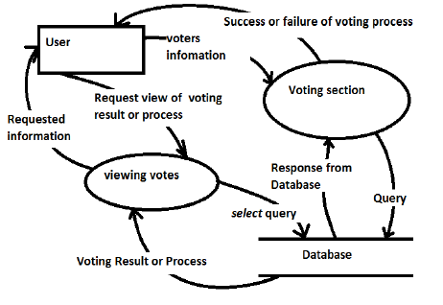

**ER Diagram**

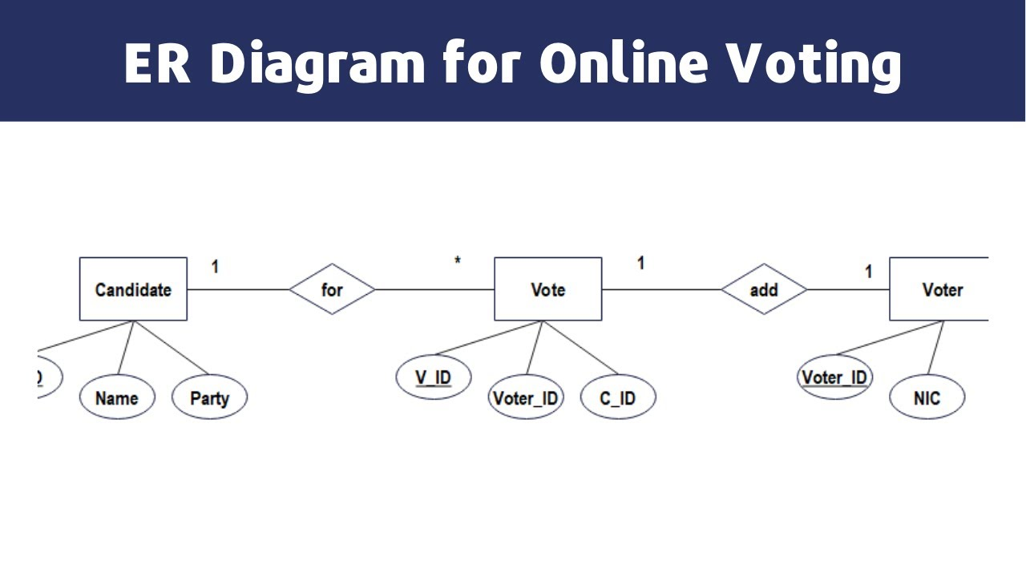

**Use Case Diagram**



**Class Diagram**

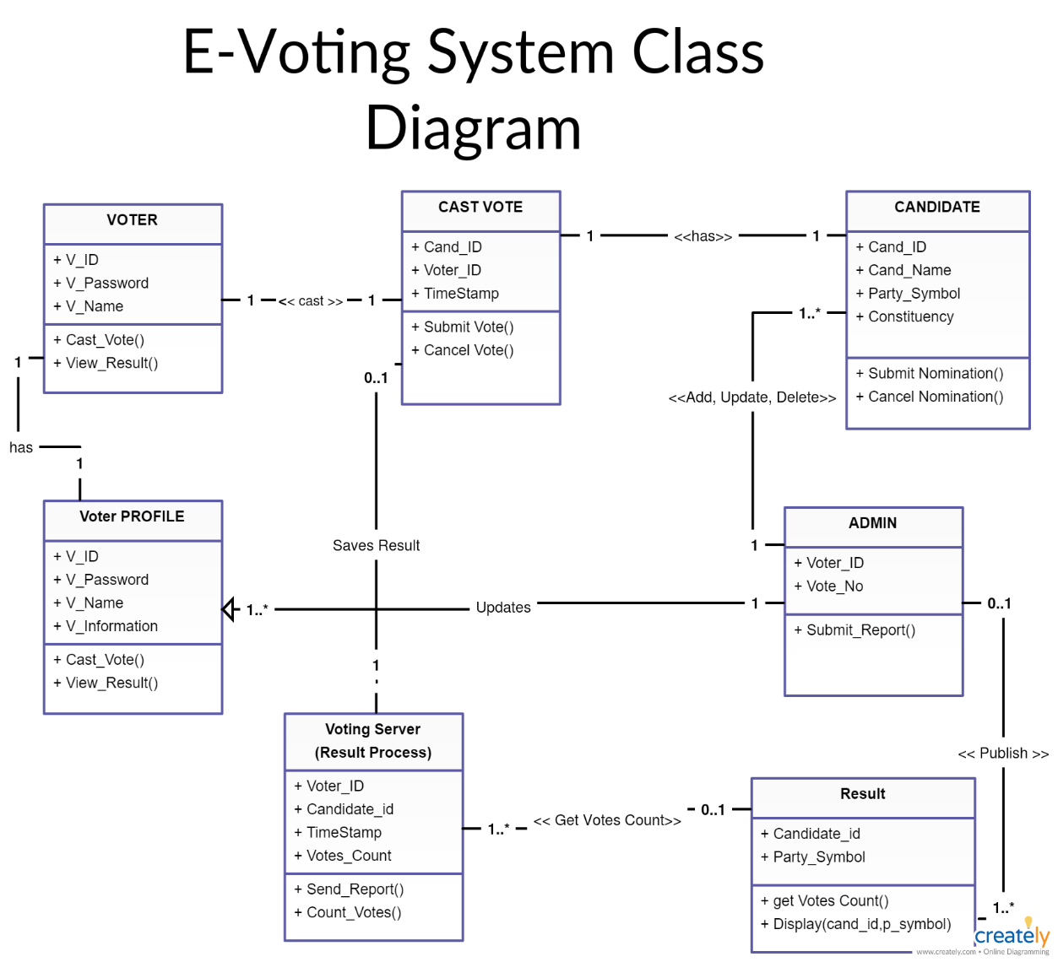

**Sequence Diagram**

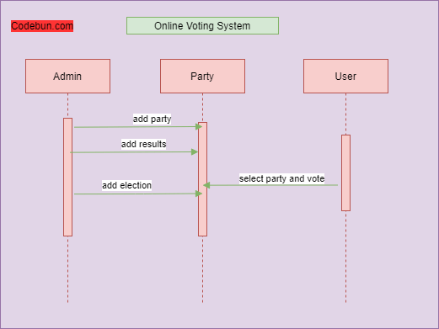

**Activity Diagram**



**Deployment Diagram**

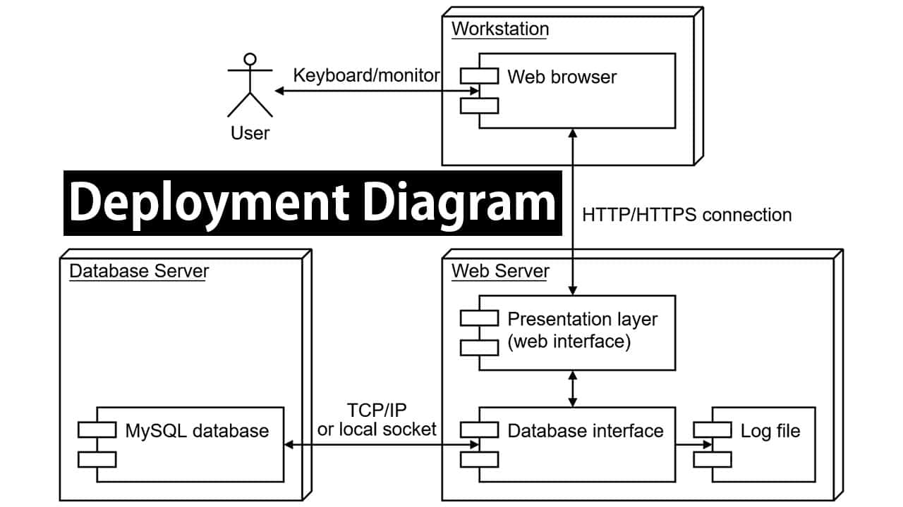

**System Architecture**

* **Client-Server Architecture**: The system will follow a client-server model, with the client side handling the user interface and the server side managing business logic and data storage.

**Test Cases**

* **User Authentication**: Test cases for verifying user login, OTP verification, and biometric authentication.
* **Vote Submission**: Test cases for ensuring secure and correct submission of votes.
* **Report Generation**: Test cases for the accurate generation of election results and audit reports.

**System Modules**

* **Voter Management Module**: Handles voter information, including registration details, voter lists, and eligibility verification.
* **Admin Module**: Provides administrative functionalities for managing elections, users, and system configurations.

**Performance Requirements**

* **Security**: Implementation of end-to-end encryption for all data transmissions to prevent unauthorized access.
* **Data Integrity**: Ensure data integrity through checksum and other validation mechanisms.

**Hardware and Software Requirements (Continued)**

* **Backup and Recovery**: Implement automated backup and recovery mechanisms to ensure data safety in case of system failures.

**Test Cases**

**User Authentication**

* **Test Case 1**: Verify successful login with correct credentials.
* **Test Case 2**: Verify OTP verification process.
* **Test Case 3**: Verify biometric authentication (if implemented).

**Vote Submission**

* **Test Case 1**: Ensure secure vote submission without data loss.
* **Test Case 2**: Verify that a vote can only be submitted once per voter.
* **Test Case 3**: Ensure votes are correctly tallied and recorded.

**Report Generation**

* **Test Case 1**: Verify accuracy of generated election results.
* **Test Case 2**: Ensure audit logs are complete and tamper-proof.
* **Test Case 3**: Test the generation of various reports, including voter turnout and vote distribution.

**Conclusion**

The Votify Online Voting System aims to revolutionize the way elections are conducted by providing a secure, efficient, and accessible platform for digital voting. By leveraging modern technologies, Votify addresses the limitations of traditional voting systems and ensures a transparent, trustworthy election process. With its focus on security, accessibility, and cost efficiency, Votify has the potential to transform democratic participation and decision-making processes worldwide.

**References**

* [**https://www.w3schools.com/html/html_basic.asp**](https://www.w3schools.com/html/html_basic.asp)
* [**https://developer.mozilla.org/en-US/docs/Learn/CSS/First_steps**](https://developer.mozilla.org/en-US/docs/Learn/CSS/First_steps)
* [**https://www.javascripttutorial.net/**](https://www.javascripttutorial.net/)
* [**https://www.w3schools.com/js/js_htmldom_document.asp**](https://www.w3schools.com/js/js_htmldom_document.asp)
* [**https://youtu.be/-mbYAj5hvLs?si=hwEY8VDB2FymlSMV**](https://youtu.be/-mbYAj5hvLs?si=hwEY8VDB2FymlSMV)
* [**https://www.w3schools.com/nodejs/**](https://www.w3schools.com/nodejs/)
* [**https://www.w3schools.com/sql/sql_intro.asp**](https://www.w3schools.com/sql/sql_intro.asp)
* [**https://icons.getbootstrap.com/**](https://icons.getbootstrap.com/)